Natural Health Online Education

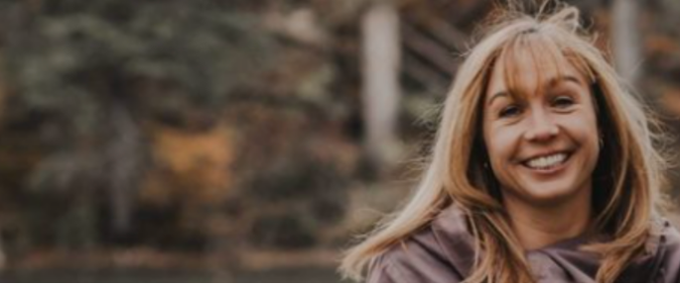

Natural Health Online Course:

Transformations Through Menopause Naturally
- 8 Weeks
- 20 Modules
- Self-paced learning
- Guided Instruction
- Two Private Sessions with Dr. Marnie
View course outline and fees
Learn to live in partnership with the next phase of your life rather than against it. Menopause can signal a powerful transiiton into an age where you feel accomplished, knowledable and professional.
But for many women, menopause can feel like an obstacle that disrupts your day.
Finding answers to your hormonal health can be challenging with all of the misinformation and contradicting information in women’s health. However with the right education and tools you will feel supported through this milestone in your life and find a healthy balance within your body.
If you want to take control of your own health, learn how to live with menopause, figure out your hormones, sleep soundly, optimize your metabolism, and stabilize your mood then this course is for you.
To get access to this course, complete your free 15 minute introductory call with Dr. Marnie. Book today and get your questions answered.


Are you ready for a change?
I work with women every day and help them feel better after menopause than they did before menopause.
I am an accredited naturopath with over 16 years of experience helping women live their best lives. As a woman going through menopause myself I want to teach you how to embrace this powerful time in your life and harness the incredible joy it can bring when you learn how to work with your body rather than against it.
This online course targets three goals during menopause:
- Improved metabolism
- More energy to enjoy life
- Better sleep
View course details
Together, let’s make your best health a reality.

Let’s talk about results
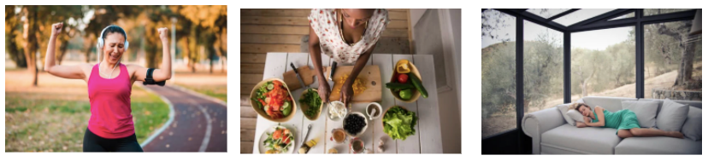
Every day, clients are raving about their wins:
⇨ They lost their first 5 lbs
⇨ They are back in control of their bodies
⇨ They have great sleeping habits
⇨ They are reaching their goals
These are the kinds of results our clients are sharing.
The only question you need to ask yourself is, “Do I want to be in my best health after menopause?”
If the answer is YES, then I’d love to share with you how we’re getting these kinds of results in a FREE introductory call.
BOOK YOUR FREE CALL

Not Ready to commit to an 8 week course?

Join the Facebook group and get access to:
◯ Educational posts
◯ Hormone education
◯ Support with insomnia, fatigue, how to stabilize your mood, and more.
The group is filled with valuable, proven, evidenced-based information and members who can support you through the transitions of menopause. Together, you will learn how to flourish in the world in a whole new way.


